Course: Data Structures (CSE CS203A)
Assignment V: Tree

Due date: 2025.12.30 23:59:59

Important Notice – Use of AI Tools
In this assignment, you must use at least one AI assistant (e.g. ChatGPT, Gemini, Claude, Grok, M365 Copilot) as a learning tool to help you:
- review definitions,
- compare tree variants, and
- organize your report.
You are not allowed to let the AI directly produce your final diagrams or final report content without your own understanding and rewriting.
You must log all AI prompts and services used (see “AI Usage Log” section below).

Goal of This Assignment
In the lectures, we introduced the concept of the tree as a data structure, starting from the general tree and then moving to more specialized forms.
In this assignment, you will:
- Understand and clearly define:
  - General tree
  - Binary tree
  - Complete binary tree
  - Binary search tree (BST)
  - AVL tree
  - Red-Black tree
  - Max heap
  - Min heap
- Build a hierarchy and transformation path from the general tree to these variants, and explain how each variant adds more structure or constraints.
- Use a fixed list of integers to construct multiple tree variants and visualize them.
- Choose one real-world application for each tree type and explain why that data structure fits the application.
- Practice using AI tools as study companions and keep a simple Q&A log.

Given Data
Use the following 20 integers as the input data for all your tree constructions:
37, 142, 5, 89, 63, 117, 24, 176, 58, 133, 92, 11, 151, 72, 39, 184, 7, 101, 54, 160
You will reuse this same sequence for every tree type (binary tree, complete binary tree, BST, AVL, Red-Black, max heap, min heap).

Deliverables
Please complete your work in the Student Worksheet Companion and upload it to the YZU Portal System.
Your report should include the following parts:
- Definitions (Concept Review)
Provide clear, concise definitions for each of the following:
- General tree
- Binary tree
- Complete binary tree
- Binary search tree (BST)
- AVL tree
- Red-Black tree
- Max heap
- Min heap
You are encouraged to use AI tools to help you understand these concepts, but you must rewrite the definitions in your own words.
- Hierarchy and Transformation of Tree Variants
Based on the definitions above, build a “tree family hierarchy” that shows how these structures are related. For example:
- General tree → Binary tree
- Binary tree → Complete binary tree / Binary search tree
- BST → AVL tree / Red-Black tree
- Binary tree → Max heap / Min heap
Tasks:
- Draw a diagram or flow chart that shows the transformation or specialization path:
general tree → binary tree → complete binary tree → BST → AVL/Red-Black, etc.
- For each arrow (transformation), briefly explain:
  - What new constraint or property is added?
  - e.g., “Binary tree = tree with at most 2 children per node”,
“BST = binary tree with left < root < right”,
“AVL = BST with strict height-balance rule”, etc.
- Tree Construction with the Given Integers
Using the given 20 integers, construct the following tree variants:
- Binary tree
- Complete binary tree
- Binary search tree (BST)
- AVL tree
- Red-Black tree
- Max heap
- Min heap
Important Hint / Restriction:
- For these trees, you must use tree visualization tools (e.g., online visualizers or software) to build and display the tree.
- You may not ask AI tools to directly generate the final tree pictures for you.
- Instead:
  - Use AI only to help you understand algorithms,
  - Then apply those algorithms in a visualizer (or your own implementation).
What to submit for this part:
For each tree type:
- A snapshot (image) of the constructed tree.
- The URL / name of the visualization tool you used.
- A short note on how you inserted the integers (e.g., “insert in the given order as BST”, “build max heap using heapify”, etc.).
- Application Example for Each Tree
For each of the following:
- Binary tree
- Complete binary tree
- Binary search tree (BST)
- AVL tree
- Red-Black tree
- Max heap
- Min heap
Choose one application (real-world or system-level) and explain:
- Application description
  - e.g., priority scheduling, dictionary lookup, memory allocation, database indexing, etc.
- Why this tree structure fits
  - What property of this data structure makes it suitable?
  - Example:
    - Max heap → good for priority queue because the largest element is always at the root, so extracting max is efficient.
    - Red-Black tree → good for standard library maps/sets because it guarantees O(log n) operations even under many insertions/deletions.
Your explanation should show that you understand the link between the data structure and its use case.
- Report Layout and Organization
You are free to design the layout of your report, but it should:
- Be well-structured (use sections, headings, tables, and diagrams).
- Have a clear flow from:
  - definitions →
  - hierarchy/transformation →
  - constructed trees →
  - applications →
  - AI usage log.
- Be easy for another student to read and learn from.
Feel free to use AI to suggest a good outline, but you must decide and finalize the layout yourself.
- AI Usage Log (Q&A Table)
Every time you use an AI copilot service for this assignment, record:
- Index (1, 2, 3, …)
- Prompt (what you asked)
- Service (e.g., ChatGPT, Gemini, Copilot, …)
Example log table:
Index | Prompt | Service
1 | Assist me to have the definition of general tree, binary tree, complete binary tree, binary search tree, AVL tree, red-black tree, max heap and min heap for self-learning. | ChatGPT
2 | Explain the difference between AVL tree and Red-Black tree in terms of balancing strategy and use cases. | Gemini
… |  | …
Place this table at the end of your report.

Evaluation (100 pts)
A possible breakdown (you can adjust if needed):
- Concept definitions (20 pts)
  - Correctness and clarity of all 8 tree type definitions.
- Hierarchy & transformation explanation (20 pts)
  - Clear diagram / explanation of how each tree variant evolves from the general tree.
  - Correct identification of constraints/invariants.
- Tree constructions & visualizations (25 pts)
  - Correct constructions for each tree type using the given integers.
  - Proper screenshots and tool URLs.
  - Consistent insertion / heap-building strategy descriptions.
- Applications & explanations (20 pts)
  - One application per tree type.
  - Clear explanation linking data structure properties to the application.
- Report organization & AI usage log (15 pts)
  - Logical report structure and readability.
  - AI log completeness (all prompts listed with service names).
  - Thoughtful use of AI as a learning assistant, not as a copy-paste generator.

Course: Data Structures (CSE CS203A)
Assignment V: Tree
Student Worksheet Companion

Due date: 2025.12.30 23:59:59

Academic Integrity and AI Usage Statement
In this assignment, you must use AI tools (such as ChatGPT, Gemini, Claude, Grok, M365 Copilot, etc.) as learning assistants, but you must also take full responsibility for understanding and organizing your own work.

Permitted Use of AI Tools
You may use AI to:
- Review or clarify definitions and concepts.
- Compare different tree data structures.
- Get suggestions for report layout or examples.
- Ask for explanations of algorithms (e.g., BST insertion, AVL rotation, heapify process).
You should read, think about, and rewrite the content in your own words.

Not Permitted
- Do not copy/paste AI-generated content directly as your final answer.
- Do not ask AI to draw the final diagrams or directly produce the final tree screenshots.
- Do not ask AI to complete the whole assignment report for you.

Your Responsibility
- You are responsible for understanding the definitions and algorithms.
- You are responsible for verifying whether AI answers are correct or not.
- You must produce your own original explanations and diagrams.

AI Usage Log
- You must record all AI queries related to this assignment.
- At the end of your report, include an AI Usage Log table with: Index, Prompt, AI service name.
By submitting this assignment, you acknowledge that you have used AI tools only as study aids, and that the final content of this assignment represents your own understanding and work.

Section 1. Definitions of Tree Variants
Task: Write your own definitions for each tree type. You may use AI for learning, but rewrite in your own words.
- General Tree
Definition:
如同自然界樹根類似，由根、分支與節點以階層方式組成
沒有節點的樹稱為Empty tree
根節點只有一個(於最上層)，分支與子節點數量不限
沒有cycle(即只能往下一層走，不能回頭或在同一層移動)

- Binary Tree
Definition:
在一般樹的基礎下，加入了「子節點只能有至多兩個的限制(Degree<=2)
分別是左子節點與右子節點(左子樹與右子樹)」的限制。

- Complete Binary Tree
Definition:
在二元樹的基礎下，加入了「除了最後一階層(最下面那一階)所有子節點之外，所有其他階層的子節點都被填滿(即Degree = 2)，沒填滿的部分則由左到右填」的限制。

- Binary Search Tree (BST)
Definition:
在完全二元樹的基礎下，加入了「對於一個節點數不為零的完全二元樹，左子樹中的所有子節點的值比根集合的值小，右子樹中的所有右子節點集合比根集合大」的限制。

- AVL Tree
Definition:
在BST的基礎下，加入了平衡因子Balance Factor:「在樹中的每一個節點，左子樹與右子樹高度差不能超過一層(絕對值)。」

- Red-Black Tree
Definition:
- 根節點是黑色
- 子節點不是紅色就是黑色
- 不能有(相鄰)連續兩個紅色節點
- 所有的葉子(NIL節點)都是黑色
- 從任一節點到葉節點的路徑，黑色節點數都相等

- Max Heap
Definition:
  - 必須是BST
  - 除了根節點外，所有父節點的值都大於等於其子節點

- Min Heap
Definition:
  - 必須是BST
  - 除了根節點外，所有父節點的值都小於其子節點

Section 2. Tree Family Hierarchy and Transformations
Task: Show how these structures are related (general → specialized). Use a simple diagram and explanations of what constraints are added at each step.
2.1 Tree Family Diagram
You may draw this by hand and paste a photo, or use drawing tools.
Suggested chain example (you may extend or adjust):
General Tree → Binary Tree → Complete Binary Tree

Binary Tree → Binary Search Tree → AVL / Red-Black

Binary Tree → Max Heap / Min Heap

Your Diagram:
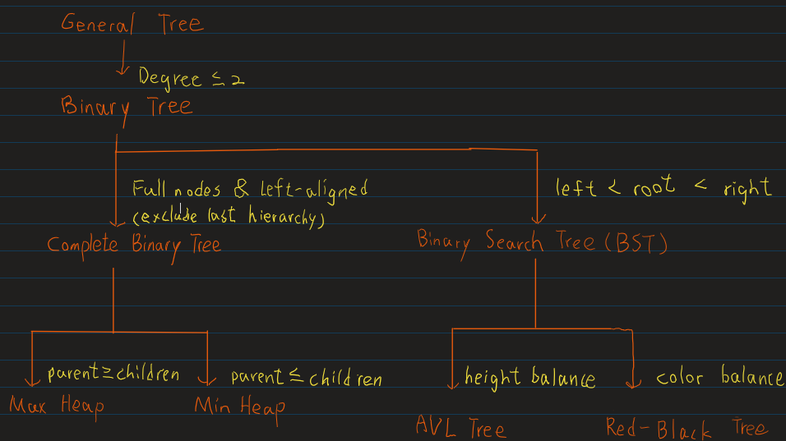

2.2 Explanation of Transformations
Fill in what new property or constraint is added at each step.
From | To | New property / constraint added
General Tree | Binary Tree | For each node, its child Nodes <= 2
Binary Tree | Complete Binary Tree | Every hierarchy is full of node except the last one, the node should be left-aligned (from left to right)
Binary Tree | Binary Search Tree | For each node, the value of left child node should less than the parent node, and the value of right child nodes should greater than the parent node
BST | AVL Tree | Include balance factor, which means the height of left subtrees and right subtrees should be nearly the same (no greater or less than 1)
BST | Red-Black Tree | Balancing the tree via red/black colors instead of the height of subtrees, containing rules below:  - no consecutive red nodes,  - Leaf nodes are always black, traverse to every leaf node should have the same number of black nodes, and  - The root node is always black.
Binary Tree | Max Heap | Usually based on the Complete Binary Tree (Every hierarchy is full of node except the last one, the node should be left-aligned), root node is always the greatest, child nodes are always less than the parent nodes.
Binary Tree | Min Heap | Usually based on the Complete Binary Tree (Every hierarchy is full of node except the last one, the node should be left-aligned), root node is always the smallest,  child nodes are always greater than or equal to the parent nodes.

Section 3. Tree Constructions Using Given Integers
Given integers (fixed for all parts):
37, 142, 5, 89, 63, 117, 24, 176, 58, 133, 92, 11, 151, 72, 39, 184, 7, 101, 54, 160
Task: For each tree type below, construct the tree using these integers, take a screenshot of the tree from your chosen tool, record the tool name/URL, and describe the insertion / heap-building procedure.
3.1 Binary Tree
Tool name / URL:
Binary Tree and Graph Visualizer
https://treeconverter.com/

Construction / insertion description:
如同排隊入座一般，不在意數值大小，只是一序由上而下，由左而右填入。
(稱為層序插入 (Level Order Insertion) 模式)
Screenshot of Binary Tree (paste below):
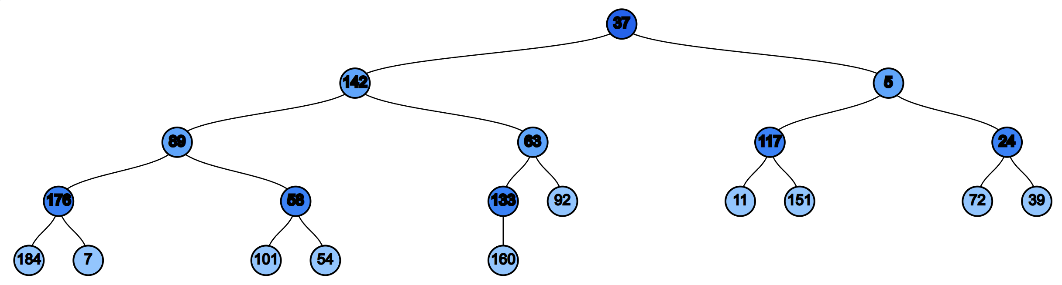

3.2 Complete Binary Tree
Tool name / URL:
USFCA Data Structure Visualization
https://www.cs.usfca.edu/~galles/visualization/Heap.html

Construction / insertion description:
(找不到純Binary Search Tree，所以用基於BST實作的MinHeap代替)插入的節點會先到目前的最下一層的左邊依序填滿，再根據其父節點一一往上比較交換數值。

Screenshot of Complete Binary Tree (paste below):
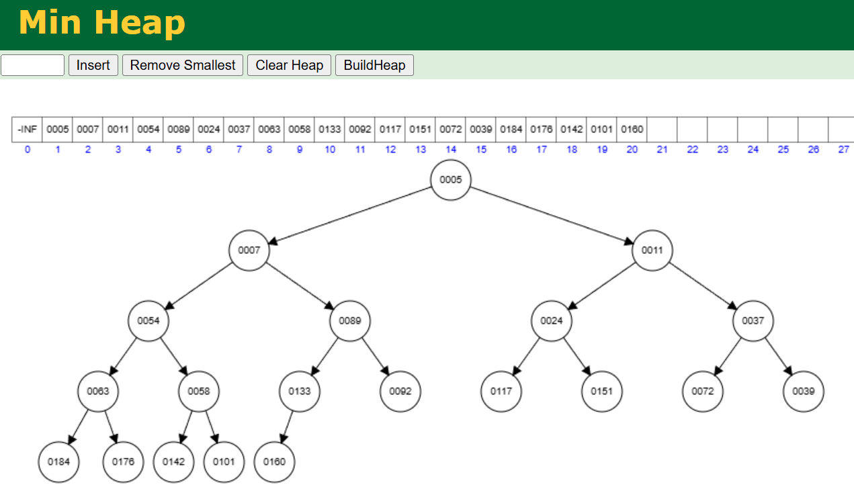

3.3 Binary Search Tree (BST)
Tool name / URL:
USFCA Data Structure Visualization
https://www.cs.usfca.edu/~galles/visualization/BST.html

Insertion rule (e.g., “insert in given order using BST rules”):
形狀像一串串果實飽滿度不一的葡萄，子數階層並不平衡。
比較大的數會被放在右側，較小的數被放在左側。
Screenshot of BST (paste below):
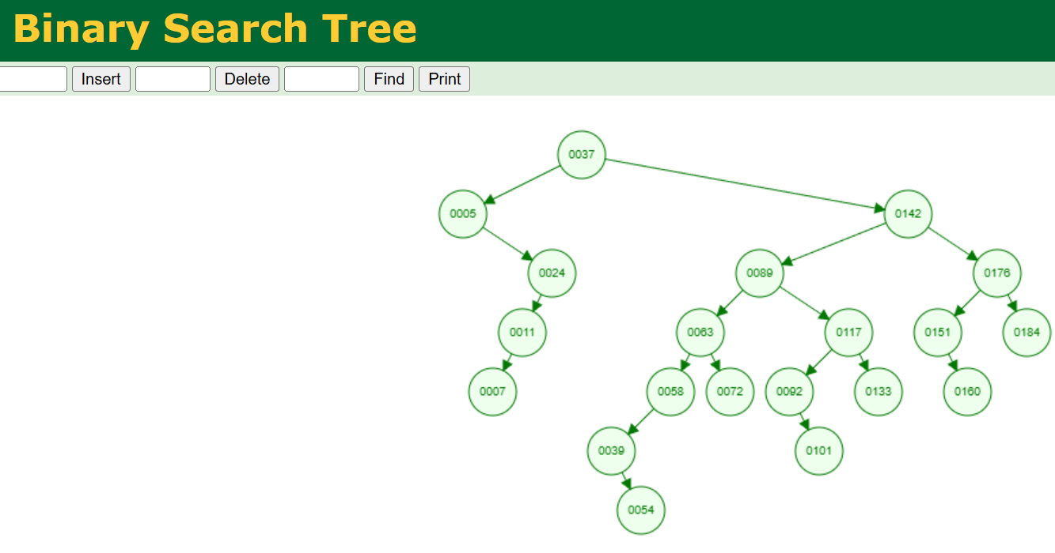

3.4 AVL Tree
Tool name / URL:
USFCA Data Structure Visualization
https://www.cs.usfca.edu/~galles/visualization/AVLtree.html

Insertion & balancing description:
節點右上角有小數字紀錄階層(最底下為1)，如果左右高度相簡大於等於2，代表階層差異過大，就會和鄰居合併(做旋轉)。

Screenshot of AVL Tree (paste below):
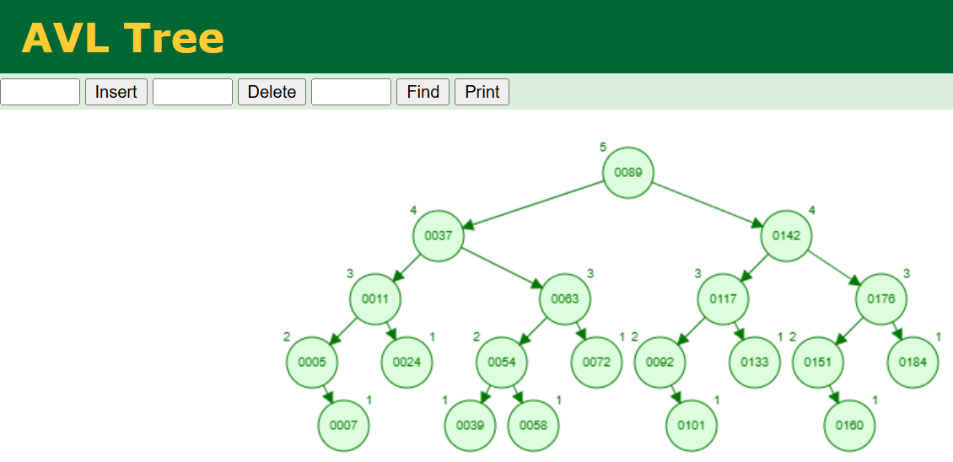

3.5 Red-Black Tree
Tool name / URL:
USFCA Data Structure Visualization/https://www.cs.usfca.edu/~galles/visualization/RedBlack.html

Insertion & balancing description:
新插入的節點預設為紅色
遇到兩個連續的紅色節點時會根據Uncle Node決定動作:
交換階層顏色/做旋轉搭配變色維持黑色高度
一階層內所有的節點顏色是一樣的
Screenshot of Red-Black Tree (paste below):
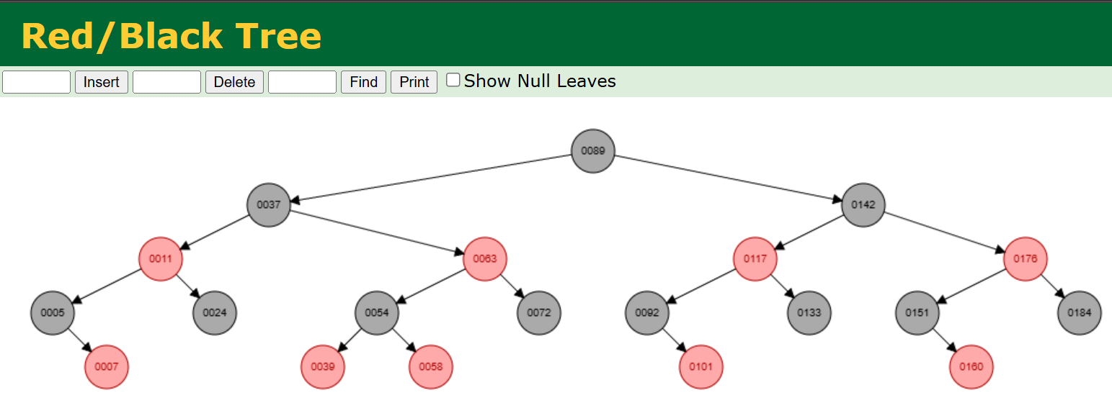

3.6 Max Heap
Tool name / URL:

Max Heap Simulator
https://sercankulcu.github.io/files/data_structures/slides/Bolum_08_Heap.html

Construction / heap-building description (e.g. heapify, insert-and-sift-up):
插入的節點會放在最後一層最左側有空位之處
比較父節點與子節點之值，子節點>父節點時交換位置
Screenshot of Max Heap (paste below):
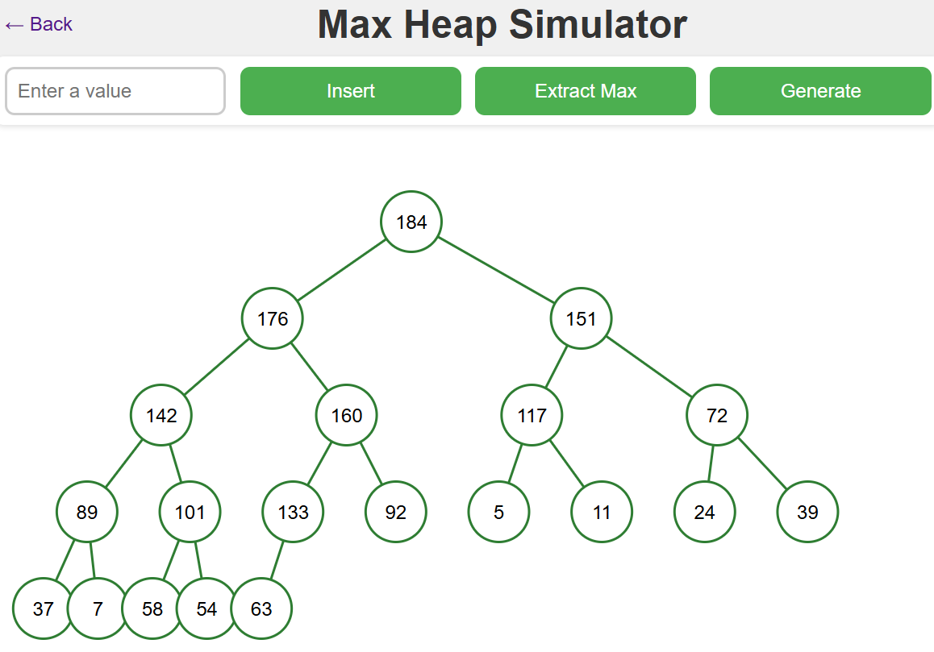

3.7 Min Heap
Tool name / URL:
USFCA Data Structure Visualization
https://www.cs.usfca.edu/~galles/visualization/BST.html

Construction / heap-building description:
插入的節點會放在最後一層最左側有空位之處
比較父節點與子節點之值，子節點<父節點時交換位置

Screenshot of Min Heap (paste below):

Section 4. Application Examples
Task: For each tree type, choose one application and explain why this tree is suitable.
Tree Type | Application Example (name / context) | Why this tree fits (properties that matter)
Binary Tree | 摩斯密碼 (Morse Code)  將英文字母編碼成點 (.) 與線 (-) 的系統。 | 每個節點只有兩條路（左邊是點、右邊是線），非常直觀地呈現了二元樹「非左即右」的結構特性。
Complete Binary Tree | 球類錦標賽賽程表 (Tournament Schedules)  如溫布頓網球賽或 NBA 季後賽的晉級圖。 | 比賽從外圍（第一輪）層層打上去直到決賽（Root），且賽程通常是排滿的（或者有人輪空補位），結構上與 Complete Binary Tree 高度相似。
Binary Search Tree | 手機通訊錄搜尋 (Contact Search)  在聯絡人清單中找「黃鈺峰」。 | 利用「左小右大」的排序特性，我們不用從第一個人滑到最後一個，而是可以用二分法的概念快速定位到「王」姓開頭的區域。
AVL Tree | 電子字典/拼字檢查 (Spell Checker)  查詢一個單字是否存在於字典中。 | Strict Balance (Read-Optimized):  字典裡的字一旦建好就不常改（插入少），但每天被查詢幾萬次（讀取多）。AVL 的嚴格平衡保證了查詢速度最快，非常適合這種「讀多寫少」的場景。
Red-Black Tree | 手機多工處理/排程 (Process Scheduler)  作業系統決定哪一個 App 可以使用 CPU（如 Linux CFS）。 | General Balance (Update-Optimized):  手機 App 開開關關（插入/刪除）非常頻繁。紅黑樹在變動資料時的調整成本比 AVL 低，能更流暢地處理這些頻繁的狀態改變。
Max Heap | 急診室檢傷分類 (Emergency Room Triage)  決定哪位病人要先看醫生。 | Priority (Max First):  這裡不看「誰先來」，而是看「誰最嚴重」。Max Heap 能保證隨時抓出來的都是優先權最高（傷勢最重）的病人，確保救命效率。
Min Heap | Dijkstra's Algorithm (Shortest Path)  地圖導航中尋找最短路徑的演算法。 | Priority (Min First):  根節點永遠是最小值，能夠快速從未訪問的節點中抓出「距離起點最近」的那個節點，大幅提升演算法效率。

Section 5. Reflection on Tree Family and Performance (Optional but recommended)
Among BST, AVL, and Red-Black trees, which one would you pick for:
Mostly search (few updates)? Why?

Frequent insertions and deletions? Why?

If you must store these 20 integers for static search only (no updates), which structure or representation would you prefer (sorted array + binary search, BST, AVL, etc.)? Why?

Section 6. AI Usage Log (Required)
Task: Record every time you ask an AI assistant about this assignment.
Index | Date / Time | AI Service (ChatGPT, Gemini, etc.) | Your Full Prompt / Question
1 | 12/13 17:26 | Gemini 3(啟用引導式學習) | 資料結構作業V實作  這份作業主旨在了解Tree的定義以及各種變體 然後透過電腦網站模擬tree的插入並觀察過程紀錄 最後每一次使用AI都要紀錄prompt以及instructions  現在我要從1.Tree的定義開始  總共有這些:  1. General Tree  2. Binary Tree  3. Complete Binary Tree  4. Binary Search Tree (BST)  5. AVL Tree  6. Red-Black Tree  7. Max Heap  8. Min Heap
2 | 12/13 18:48 | Gemini 3(啟用引導式學習) | (貼上第二部份的題目敘述)是否和我理解的一樣 (是要用網站模擬Tree的插入並截圖)。
3 | 12/13 20:38 | Gemini 3(啟用引導式學習) | 協助歸納表格，指出從 General Tree 演變至 Heap 或 AVL 時增加的具體規則。
4 | 12/14 00:09 | Gemini 3(啟用引導式學習) | 針對Section 4. Application Examples舉貼近生活中的應用實例
You may extend this table as needed.

